

SURF CITY SEASON STARTER TOURNAMENT
Pickleball Fun-D-Raiser Registration
Saturday, June 6, 2026
Rain date: June 7, 2026
Location: Surf City Pickleball Courts (Division Ave)
Event Information:
- Fee: $40
  - Make the check payable to ‘Surf City Vol. Fire Co. #1 and EMS’
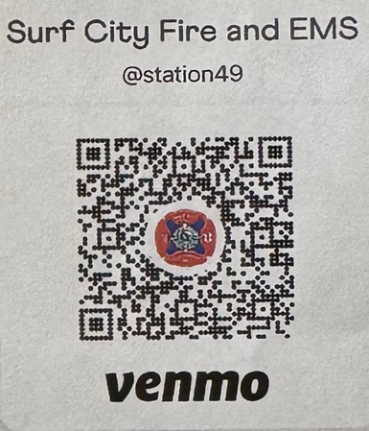
  - Venmo: Surf City Fire and EMS @station49
- Proceeds to benefit Surf City Fire and EMS (Charity Event)
- Men’s Double Play (max. 16 teams)
- Women’s Double Play (max. 16 teams)
- Random team pairing
- Questions/Concerns reach out to:
Barbara Boetticher (732-687-0821)
Donna Fiore (973-493-5188) | damfiore@gmail.com
Registration Information:
Name
Phone Number
Email
Gender (circle one) | Male | Female
Purchase Visor ($20) | Yes | No

Registration ($40): __________________
Visor Purchase ($20/each): __________
TOTAL: _____________________________

